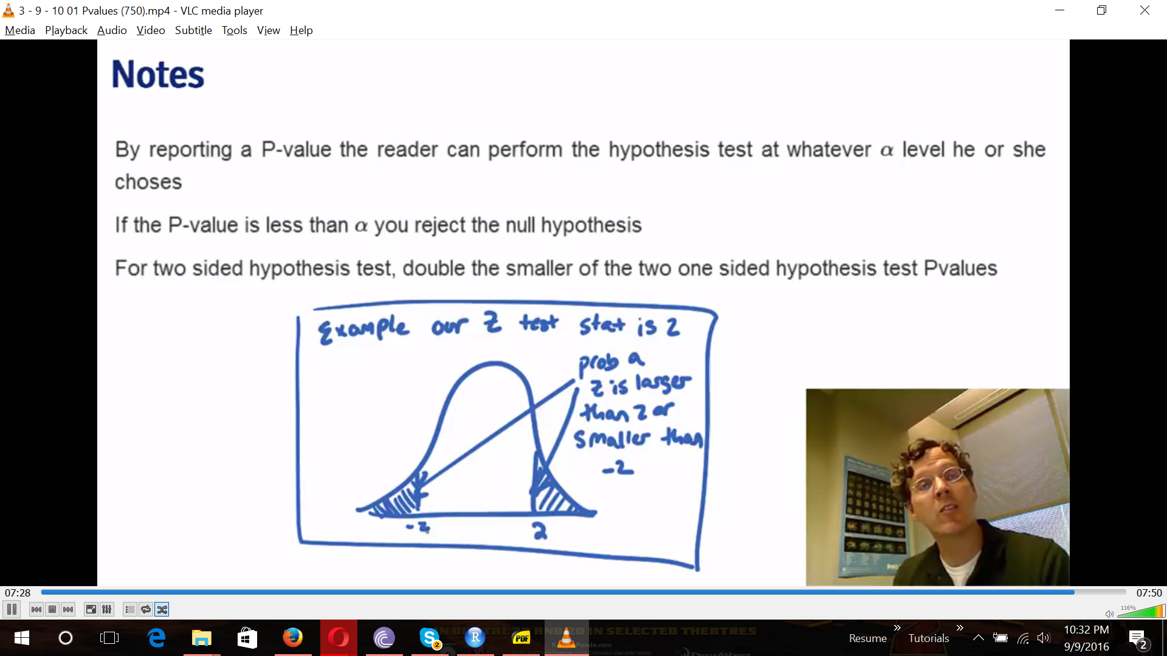

If the P-Value is less than alpha you reject the null hypothesis